# LTspice – Electronic circuit simulator

LTspice for Windows and Mac can be downloaded through (no account is required): https://www.analog.com/en/design-center/design-tools-and-calculators/ltspice-simulator.html. This manual is based around version XVII

Unlike board-level designs composed of discrete components, it is not practical to breadboard integrated circuits before manufacturing. Further, the high costs of photolithographic masks and other manufacturing prerequisites make it essential to make sure that the circuit is as close to perfect as possible before the integrated circuit is made. Simulating the circuit with SPICE is the industry-standard way to verify circuit operation at the transistor level before committing to manufacturing an integrated circuit. LTspice is a free, but still very powerful SPICE simulator which you will use to design your circuit.

The template which is the base for your simulations is ‘NMOS_EKL_digital_template.asc’ or ‘NMOS_EKL_analog_template.asc’, depending on the chosen assignment. Beside this you will need the SPICE model of the NMOS transistor, which has been based on measurements performed on actual transistors. This model, ‘nmosekl.lib’ must be in the *same* directory as the *.asc template.

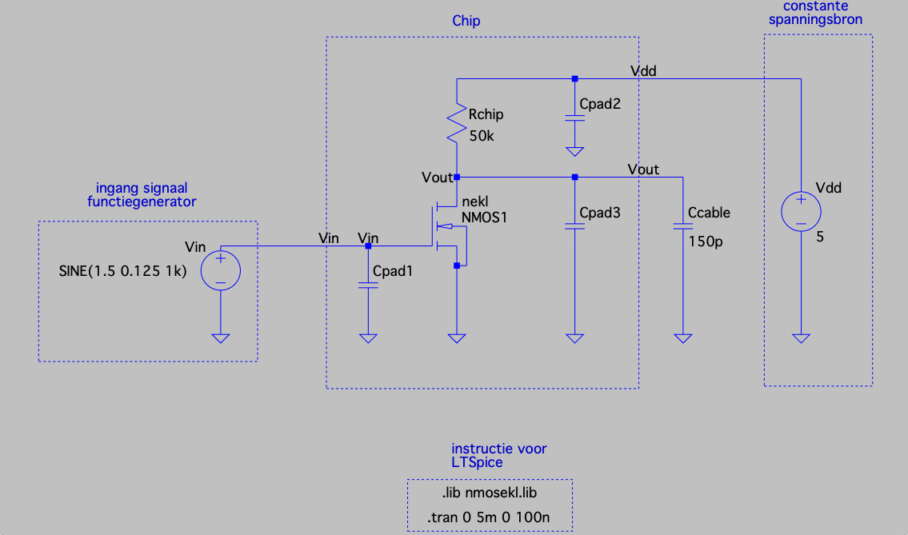

Figure 1: Main LTspice window with digital template. Note that the value of Cpad1, Cpad2 and Cpad3 are removed from this screenshot but should be added by you!

After opening the model, you should get a screen as shown in Figure 1. You can see the four-terminal NMOS1 (the 4th terminal is the bulk which is connected to ground) and the on-chip resistor (Rchip). Beside these two components which will be fabricated on the actual chip, also three parasitic capacitors underneath the contact pads and the capacitance of the cable used during the measurements after fabrication are added as these have a significant impact on the circuit. You will have to calculate the values of the contact pad capacitance yourself! Finally, the external power supply (Vdd) and input source (Vin) are there to complete the circuit.

Editing parameter values

You will have to optimize the dimensions of the transistor (its length (L) and width(W)) and the resistance value of Rchip - and the value of the DC offset for the analog assignment - to reach the desired circuit performance as specified in the design assignments. Component values in the simulator can be changed by right-clicking on the symbol, after which you will get a pop-up window which allows you to change the value. For the resistor you can change the resistance; for the transistor, its length and width (Figure 2).

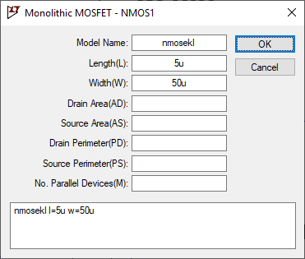

Figure 2: Example of parameter change dialog for the transistor

**Hints:** you do not have to add the units in the software. However, you should use the unit prefixes to get the correct results (table 1). For instance, a 20 kΩ resistor has a value for its resistance 20k.

For the NMOS the L and W should be specified in µm: e.g. 5u for the length and 200u for the width. Use realistic values for the transistor: < 1 mm for the width. It is better to reduce the L then to keep increasing W (remember, they are a ratio). Do not change the name of the NMOS1 model!

Table 1: LTSpice prefixes used when setting component values

|  |  |
| --- | --- |
| SI Prefix | Prefix in LTspice |
| pico | p |
| nano | n |
| micro | u |
| milli | m |
| kilo | k |
| mega | M |
| giga | G |

Running simulations

Transient (time-based) simulations are used to see how voltages and current in a circuit change over time. The templates for the digital and analog are already set-up in such a way that the simulations work for the default values of the pulse or sine source. However, you might need to change them during the design assignment if you change the frequency of the source. This can be done by clicking on *Simulate – Edit Simulation Cmd*, after which you can change the stop time and maximum time step. The stop time determines how many periods you simulate, the time step the time between simulation points. A very small timestep will cause the simulations to take a longer time, but a too large time step will impact accuracy.

A simulation can be run by selecting *Simulate – Run*. A black or white empty window should now pop-up. Now add the traces V(vout) and V(vin) by right clicking on the empty simulation window and using the ‘*Add Traces*’ option. You should get the results as shown in Figure 3. A grid can be displayed in the plot by pressing Ctrl + G, or using right-click – *View - Grid*. In this View menu, also other things can be edited, and the images can be copied to the clipboard for saving in your favorite picture editor (e.g. Paint or Paint.NET). Feel free to play with the software to explore other options!

It is possible to also add calculations to the plot window. For instance, we can add the power dissipated by the resistor. We know that P = U∙I, and that the potential drop over the resistor equals Vdd - Vout. Therefore the power through the resistor can be plotted by adding the trace: ‘(V(vdd)-V(vout))*I(Rchip)’. The axis should display the correct units (Watt).

**Hint:** by default, waveform windows in LTspice have a black background. To change this, select the icon of a hammer in the menu bar (or select *Tools – Control Panel*). Select the Waveforms tab and click ‘color scheme’. Select Background in the drop-down menu and change all values to 255 to get a white background. This provides prettier and more readable images to save or print. Furthermore, you can add a grid by enabling it when you right-click on the simulation plot and navigate to ‘View’.

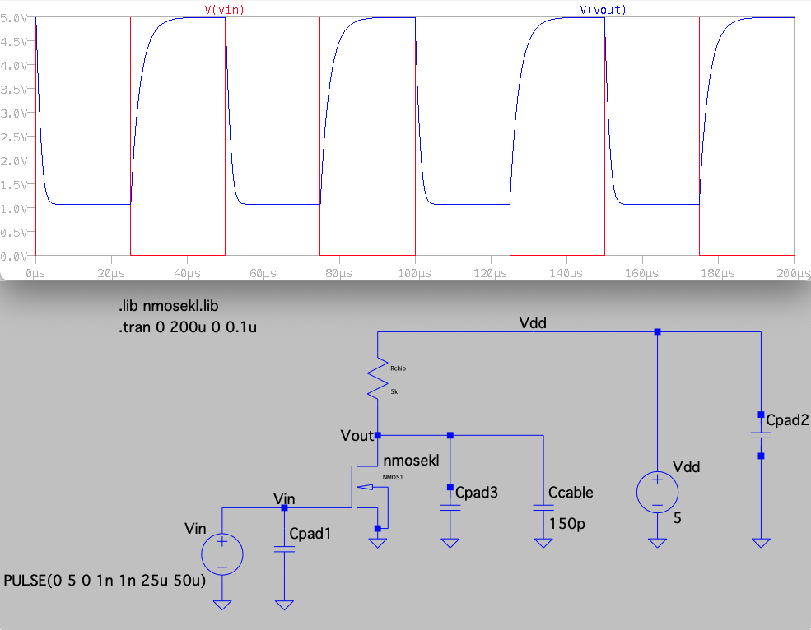

Figure 3: Example of transient simulation for a pulse input source as used in the digital assignment. Note that the value of Cpad1, Cpad2 and Cpad3 are removed from this screenshot but should be added by you!

**Hint to add cursor:** By left clicking on the name of the trace (e.g. V(vout) in the figure 3) it is possible to add a cursor to a trace in order to read out the values. You can drag the cursor by moving your mouse near the cross till a ‘1’ or ‘2’ shows and then hold the left mouse button.

**Hint on editing traces:** By right-clicking on the name of the trace you can adjust it. For instance, if you want to remove a DC offset when working with the analog amplifier you can subtract it here to make it easier to observe the AC gain.